Session 4

Install (in a container, if necessary or preferred) each DBMS listed below in the version of your choosing in the operating system of your choosing. Create in each one a small example data base with at least one table and populate that with at least one record. Please document all the steps you take and their outcome in your response, properly citing all the guides you followed in the process.

Before all installations, install Homebrew on my Mac

* Follow instruction from brew.sh

1. SQLite (1 point)

* Download SQLite from page-download [sqlite-tools-osx-x86-3390400.zip](https://www.sqlite.org/2022/sqlite-tools-osx-x86-3390400.zip)
* Follow steps from sqlite.org/cli.html -
* Copy code from sqlite/example.sql
* Do simple example select all from grades table

2. MySQL (2 points)

* Downloaded MySQL Community Server 8.0.30 from https://dev.mysql.com/downloads/mysql/
* Follow install instruction
* Start MySQL (System Preferences/MySQL – click Start MySQL Server
* Copy the directory path of MySQL
* Open terminal and paste the directory path and add:
  + /usr/local/mysql/bin/mysql -u root -p
* Create bash profile in order to access directly to MySQL without paste the directory path
  + Open root directory
  + Verify if .bash_profile exit type this command: ls -al .b*, if no create it following this steps:
    - Touch .bash_profile. //create
    - ls -al .b* //verify if was created
    - open -t .bash_profile //open file
    - Export PATH=${PATH}:/usr/local/mysql/bin //add this line of code and save
    - Close terminal
  + Verify if my sql work, if not try this:
    - Open terminal and type;
    - sudo rm .bash_profile //remove .bash_profile file
    - sudo nano /etc/path
    - /usr/local/bin //add this below to last line
* Create dump.sql
* Follow steps from mysql/dump.sql
* Follow steps from mysql/check.sql
* All data was inserted one by one using sqlite example

# Source: <https://www.youtube.com/watch?v=CBtBZgmP22M> - Install MySQL 8.0.28 Database on MacOS Big Sur [Step-by-Step Tutorial]

3. MariaDB (2 points)

* Follow installing instruction from <https://mariadb.com/resources/blog/installing-mariadb-10-1-16-on-mac-os-x-with-homebrew/>
* Install brew
* Run brew info mariadb (ERROR No available formula…)

4. PostgreSQL (2 points)

* Postgres suggest to use Postgres.app (<https://postgresapp.com/>)
  + Not able to initialized because there was already a PostgreSQL server running.

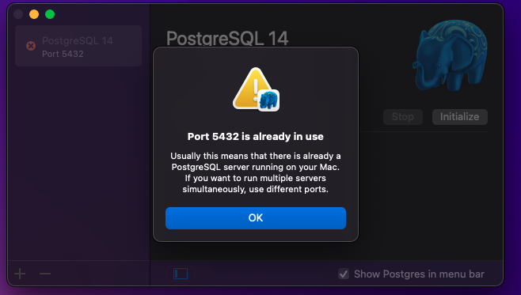

* Install using EDB – download PostgreSQL file from <https://www.enterprisedb.com/downloads/postgres-postgresql-downloads>
  + Successfully installed and ready to use pgAdmin server or terminal
  + On pgAdmin use Query Tool to create table
  + Table were create manually
  + Query SELECT * FROM students JOIN grades USING (StudentID) ORDER BY Grade;

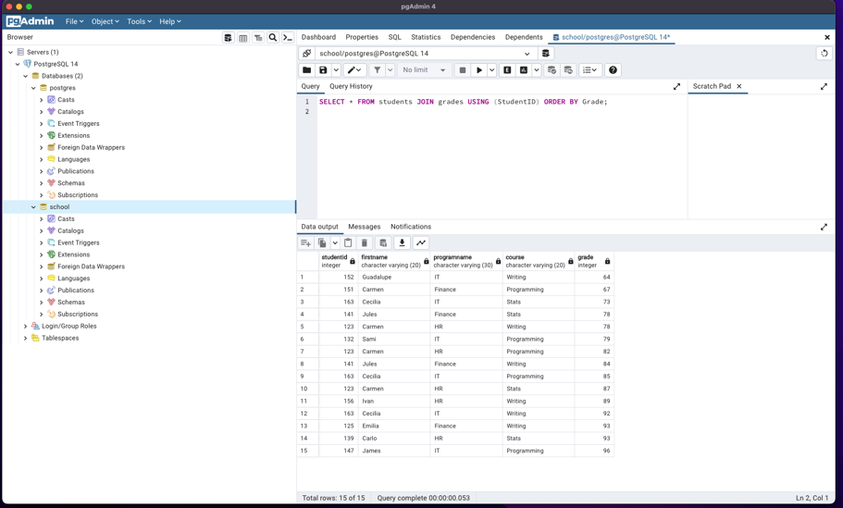

Source: https://www.youtube.com/watch?v=1aybOgni7lI

5. Microsoft SQL Server (2 points)

* Download and install docker
* Open docker
* Follow instruction from microsoft/setup.sh

* Follow steps from Microsoft/examples.sql

Source: <https://www.youtube.com/watch?v=glxE7w4D8v8>

Conclusion:

Even if brew was installed nothing works using it. I was no able to install any of the DB server wit it.

